Student Name: _______________________

Narrogin Senior High School

YEAR 11 HISTORY EXAMINATION PAPER

SEMESTER TWO 2009

HISTORY DOCUMENT BOOKLET

CONTENTS:

DOCUMENT AREA OF STUDY RELATED
SET QUESTION

- Document Germany 1919-1945 Complete all (a) – (g)
Study within answer booklet

- Essay
Questions Germany 1919-1945 Choose 1 of 3

- Essay
Questions Germany 1919-1945 Choose 1 of 3

Source 1
‘The Allied Governments affirm, and Germany accepts, the responsibility of Germany and her allies for causing all the
losses and damage to which the Allied Governments and
peoples have been subjected as a result of War.’

Article 231 of the Treaty of Versailles.

Source 2

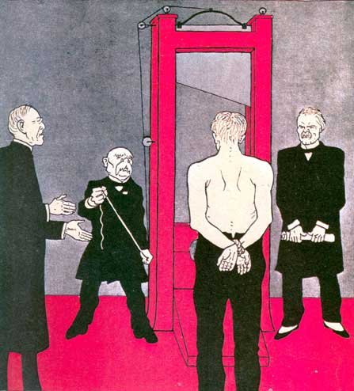

Political cartoon that appeared in the German magazine Simpliccimus on June 3, 1919.
The principal judges and executioners were (from left to right) the American President Wilson, the French President Clemenceau and the British Prime Minister Lloyd George.

Source 3

A British cartoon from Punch magazine, 8 March 1933.

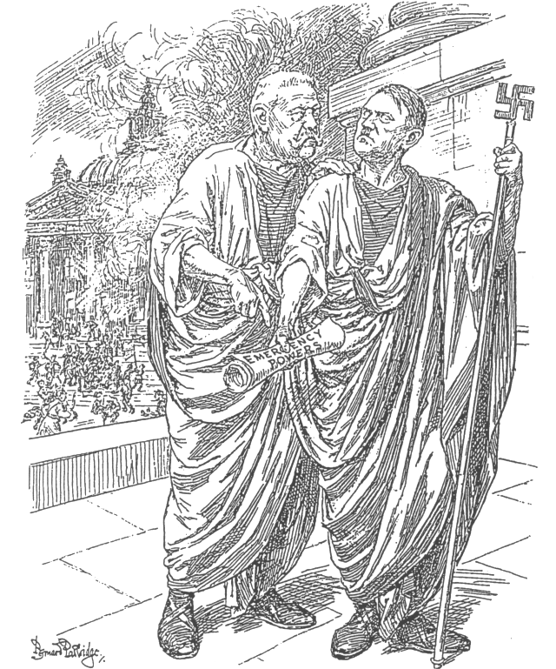

The Old Consul (to Hitler). “THIS IS A HEAVEN-SENT OPPORTUNITY, MY LAD.
IF YOU CAN’T BE A DICTATOR NOW, YOU NEVER WILL BE.

Source 4

“There had been a big Nazi meeting at the Sportsplatz (sports stadium), and groups of men were just coming away from it in their brown or black uniforms. Walking along the pavement ahead of me were three S.A. men…. All at once they came face to face with a youth of 17 or 18 dressed in civilian clothes…. I heard one of the Nazis shout ‘That’s him’, and immediately all three of them flung themselves upon the young man. He uttered a scream and tried to dodge, but they were too quick for him. In a moment they had jostled him into the shadow of a house entrance and were standing over him, kicking and stabbing at him with the sharp metal points of their banners…. Another passer-by and myself were the first to reach the doorway where the young man was lying. He lay huddled crookedly in the corner, like an abandoned sack. As they picked him up, I got a sickening glimpse of his face – his left eye was half poked out, and blood poured from the wound…. By this time, dozens of people were looking on. They seemed surprised but not shocked – this sort of thing happened too often nowadays…. Twenty yards away stood a group of heavily armed policemen. With their chests stuck out and their hands on their revolver belts, they magnificently disregarded the whole affair.
Almost every evening, the S.A. men came into the café. Sometimes they are only collecting money; everybody is compelled to give something. Sometimes they have come to make an ‘arrest’. One evening, a Jewish writer who was present ran into the telephone box to ring up the police. The Nazis dragged him out, and he was taken away. Nobody moved a finger. You would have heard a pin drop till they were gone.”

An account from an English writer living in Berlin 1932-33

Source 5

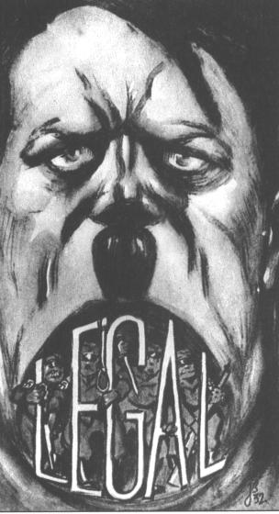

“Hitler’s interpretation of the word “legal”.

A cartoon from the Social Democrat Magazine, 1932.

Student Name: _______________________

Narrogin Senior High School

QUESTION/ANSWER BOOKLET

YEAR 11 MODERN HISTORY DOCUMENT STUDY

USA 1917 – 1941: The New Deal

SEMESTER ONE 2010

TIME ALLOWED FOR THIS PAPER

Reading and working time for the paper: 1 hour

MATERIAL REQUIRED/RECOMMENDED FOR THIS PAPER

TO BE PROVIDED BY THE SUPERVISOR

This Question/Answer Booklet
History Document Booklet

TO BE PROVIDED BY THE CANDIDATE

Standard Items: Pens, pencils, eraser, ruler

Special Items: Nil

IMPORTANT NOTE TO CANDIDATES

No other items may be taken into the examination room.

It is your responsibility to ensure that you do not have any unauthorised notes or other items of a non-personal nature in the examination room. If you have any unauthorised material with you, hand it to the supervisor BEFORE reading any further.

MODERN HISTORY

STRUCTURE OF THE PAPER

Section | Format | Area of Study | No. of questions available | No. of questions to be attempted | Marks available | Suggested Working Time (minutes)*
ONE | Document  Study | The New Deal |  | All  (a) – (f) | 25 | 50
( * Allows 10 minutes towards the end of the exam period to check your answers.)
Total marks = 25

INSTRUCTIONS TO CANDIDATES

Write all of your answers in this Question/Answer Booklet.
When using extra paper, ensure that you clearly label which question you are addressing.
If you require extra paper, put your hand up to attract attention.

There is 1 section in this paper:
- Section One - Attempt ALL of the questions (a) – (f).

At the end of the examination, check that your name has been written in the spaces provided on the front cover of this Question/Answer Booklet and on the front cover of the document booklet.

Continuity & Change: The USA 1917 - 1941

SECTION ONE: Document Study (Total: 25 Marks)
Read and examine sources one to nine and then answer the following questions.

- With reference to Source 1 outline the circumstances that saw Roosevelt elected as President of the United States
(3 marks)

____________________________________________________________________________________________________________________________________________________________________________________________________________________________________________________________________________________________________________________________________________________________________________________________________________________________________________________________________________________________________________________________________________________________________________________________________________________________________________________________________________________________________________________________________________________________________________________________________________________________________________________________________________________________________________________________________________________________________________________________________________________________________________________________________________________________________________________________________________________________________________________________________________________________________________________________________________________________________________________________________________________________________________________________________________________________________________________________________________________________________________________________________________________________________________________________________________________________________________________________________________________________________________________________________________________________________________________________________________________________________________________________________________________________________________________________________________________________________________________________________________________________________________________________________________________________________________________________________________________________________________________________________________________________________________________________________________________________________________________________________________________________________________________________________________________________________

- What message is being conveyed in Source 2?
(4 marks)

____________________________________________________________________________________________________________________________________________________________________________________________________________________________________________________________________________________________________________________________________________________________________________________________________________________________________________________________________________________________________________________________________________________________________________________________________________________________________________________________________________________________________________________________________________________________________________________________________________________________________________________________________________________________________________________________________________________________________________________________________________________________________________________________________________________________________________________________________________________________________________________________________________________________________________________________________________________________________________________________________________________________________________________________________________________________________________________________________________________________________________________________________________________________________________________________________________________________________________________________________________________________________________________________________________________________________________________________________________________________________________________________________________________________________________________________________________________________________________________________________________________________________________________________________________________________________________________________________________________________________________________________________________________________________________________________________________________________________________________________________________________________________________________________________________________________________________________________________________________________________________________________________________________________________________________________________________________________________________________________________________________________________________________________________________________________

- Compare and explain the messages and viewpoints in Source 3, Source 4 and Source 5.
(5 marks)
______________________________________________________________________________________________________________________________________________________________________________________________________________________________________________________________________________________________________________________________________________________________________________________________________________________________________________________________________________________________________________________________________________________________________________________________________________________________________________________________________________________________________________________________________________________________________________________________________________________________________________________________________________________________________________________________________________________________________________________________________________________________________________________________________________________________________________________________________________________________________________________________________________________________________________________________________________________________________________________________________________________________________________________________________________________________________________________________________________________________________________________________________________________________________________________________________________________________________________________________________________________________________________________________________________________________________________________________________________________________________________________________________________________________________________________________________________________________________________________________________________________________________________________________________________________________________________________________________________________________________________________________________________________________________________________________________________________________________________________________________________________________________________________________________________________________________________________________________________________________________________________________________________________________________________________________________________________________________________________________________________

(d) Outline the message of Source 6.
(3 marks)

____________________________________________________________________________________________________________________________________________________________________________________________________________________________________________________________________________________________________________________________________________________________________________________________________________________________________________________________________________________________________________________________________________________________________________________________________________________________________________________________________________________________________________________________________________________________________________________________________________________________________________________________________________________________________________________________________________________________________________________________________________________________________________________________________________________________________________________________________________________________________________________________________________________________________________________________________________________________________________________________________________________________________________________________________________________________________________________________________________________________________________________________________________________________________________________________________________________________________________________________________________________________________________________________________________________________________________________________________________________________________________________________________________________________________________________________________________________________________________________________________________________________________________________________________________________________________________________________________________________________________________________________________________________________________________________________________________________________________________________________________________________________________________________________________________________________________________________________________________________________________________________________________________________________________________________________________________________________________________________________________________________________________________________________________________________________

(e) Using Source 7, Source 8, and Source 9, account for the effectiveness of Roosevelt’s New Deal programme.
(4 marks)

____________________________________________________________________________________________________________________________________________________________________________________________________________________________________________________________________________________________________________________________________________________________________________________________________________________________________________________________________________________________________________________________________________________________________________________________________________________________________________________________________________________________________________________________________________________________________________________________________________________________________________________________________________________________________________________________________________________________________________________________________________________________________________________________________________________________________________________________________________________________________________________________________________________________________________________________________________________________________________________________________________________________________________________________________________________________________________________________________________________________________________________________________________________________________________________________________________________________________________________________________________________________________________________________________________________________________________________________________________________________________________________________________________________________________________________________________________________________________________________________________________________________________________________________________________________________________________________________________________________________________________________________________________________________________________________________________________________________________________________________________________________________________________________________________________________________________________________________________________________________________________________________________________________________________________________________________________________________________________________________________________________________________________________________________________________________

- Using your knowledge of the period assess the extent to which these nine sources reflect adequately the efforts to minimise the impact of the Great Depression in the United States.
(6 marks)

__________________________________________________________________________________________________________________________________________________________________________________________________________________________________________________________________________________________________________________________________________________________________________________________________________________________________________________________________________________________________________________________________________________________________________________________________________________________________________________________________________________________________________________________________________________________________________________________________________________________________________________________________________________________________________________________________________________________________________________________________________________________________________________________________________________________________________________________________________________________________________________________________________________________________________________________________________________________________________________________________________________________________________________________________________________________________________________________________________________________________________________________________________________________________________________________________________________________________________________________________________________________________________________________________________________________________________________________________________________________________________________________________________________________________________________________________________________________________________________________________________________________________________________________________________________________________________________________________________________________________________________________________________________________________________________________________________________________________________________________________________________________________________________________________________________________________________________________________________________________________________________________________________________________________________________________________________________________________________________________________________________________________________________________________________________________________________________________________________________________________________

- To what extent are the historical experiences represented throughout the five sources, consistent with your understanding of the key political events and issues of Germany between 1919 and 1933? (12 marks)
________________________________________________________________________________________________________________________________________________________________________________________________________________________________________________________________________________________________________________________________________________________________________________________________________________________________________________________________________________________________________________________________________________________________________________________________________________________________________________________________________________________________________________________________________________________________________________________________________________________________________________________________________________________________________________________________________________________________________________________________________________________________________________________________________________________________________________________________________________________________________________________________________________________________________________________________________________________________________________________________________________________________________________________________________________________________________________________________________________________________________________________________________________________________________________________________________________________________________________________________________________________________________________________________________________________________________________________________________________________________________________________________________________________________________________________________________________________________________________________________________________________________________________________________________________________________________________________________________________________________________________________________________________________________________________________________________________________________________________________________________________________________________________________________________________________________________________________________________________________________________________________________________________________________________________________________________________________________________________________________________________________________________________________________________________________________________________________________________________________________________________________________________________________________________________________________________________________________________________________________________________________________________________________________________________________________________________________________________________________________________________________________________________________________________________________________________________________________________________________________________________________________________________________________________________________________________________________________________________________________________________________________________________________________________________________________________________________________________________________________________________________________________________________________________________________________________________________________________________________________________________________________________________________________________________________________________________________________________________________________________________________________________________________________________________________________________________________________________________________________________________________________________________________________________________________________________________________________________________________________________________________________________________________________________________________________________________________________________________________________________________________________________________________________________________________________________________________________________________________________________________________________________________________________________________________________________________________________________________________________________________________________________________________________________________________________________________________________________________________________________________________________________________________________________________________________________________________________________________________________________________________________________________________________________________________________________________________________________________________________________________________________________________________________________________________________________________________________________________________________________________________________________________________________________________________________________________________________________________________________________________________________________________________________________________________________________________________________________________________________________________

SECTION TWO: Essay Writing (Total: 30 Marks)

Select only one of the three choices below.

- Evaluate the social, political and economic conditions that challenged the Weimer Republic in relation to the impact this had on stability within Germany.

- With reference to the social, political and economic climate of the era, account for the rise of the Nazi party within Germany.

- Choose any one social group living within Nazi Germany other than the Jews, and present an argument from the viewpoint that life was better (or worse) for them under the Nazi regime.

____________________________________________________________________________________________________________________________________________________________________________________________________________________________________________________________________________________________________________________________________________________________________________________________________________________________________________________________________________________________________________________________________________________________________________________________________________________________________________________________________________________________________________________________________________________________________________________________________________________________________________________________________________________________________________________________________________________________________________________________________________________________________________________________________________________________________________________________________________________________________________________________________________________________________________________________________________________________________________________________________________________________________________________________________________________________________________________________________________________________________________________________________________________________________________________________________________________________________________________________________________________________________________________________________________________________________________________________________________________________________________________________________________________________________________________________________________________________________________________________________________________________________________________________________________________________________________________________________________________________________________________________________________________________________________________________________________________________________________________________________________________________________________________________________________________________________________________________________________________________________________________________________________________________________________________________________________________________________________________________________________________________________________________________________________________________________________________________________________________________________________________________________________________________________________________________________________________________________________________________________________________________________________________________________________________
____________________________________________________________________________________________________________________________________________________________________________________________________________________________________________________________________________________________________________________________________________________________________________________________________________________________________________________________________________________________________________________________________________________________________________________________________________________________________________________________________________________________________________________________________________________________________________________________________________________________________________________________________________________________________________________________________________________________________________________________________________________________________________________________________________________________________________________________________________________________________________________________________________________________________________________________________________________________________________________________________________________________________________________________________________________________________________________________________________________________________________________________________________________________________________________________________________________________________________________________________________________________________________________________________________________________________________________________________________________________________________________________________________________________________________________________________________________________________________________________________________________________________________________________________________________________________________________________________________________________________________________________________________________________________________________________________________________________________________________________________________________________________________________________________________________________________________________________________________________________________________________________________________________________________________________________________________________________________________________________________________________________________________________________________________________________________________________________________________________________________________________________________________________________________________________________________________________________________________________________________________________________________________________________________________________
________________________________________________________________________________________________________________________________________________________________________________________________________________________________________________________________________________________________________________________________________________________________________________________________________________________________________________________________________________________________________________________________________________________________________________________________________________________________________________________________________________________________________________________________________________________________________________________________________________________________________________________________________________________________________________________________________________________________________________________________________________________________________________________________________________________________________________________________________________________________________________________________________________________________________________________________________________________________________________________________________________________________________________________________________________________________________________________________________________________________________________________________________________________________________________________________________________________________________________________________________________________________________________________________________________________________________________________________________________________________________________________________________________________________________________________________________________________________________________________________________________________________________________________________________________________________________________________________________________________________________________________________________________________________________________________________________________________________________________________________________________________________________________________________________________________________________________________________________________________________________________________________________________________________________________________________________________________________________________________________________________________________________________________________________________________________________________________________________________________________________________________________________________________________________________________________________________________________________________________________________________________________________________________________________________________________________________________________________________________________________________________________________________________________________________________________________________________________________________________________________________________________________________________________________________________________________________________________________________________________________________________________________________________________________________________________________________________________________________________________________________________________________________________________________________________________________________________________________________________________________________________________________________________________________________________________________________________________________________________________________________________________________________________________________________________________________________________________________________________________________________________________________________________

SECTION THREE: Essay Writing (Total: 30 Marks)

Select only one of the three choices below.

- Compare and contrast the roles of the SA and SS.

- Explain how the nature of Hitler’s foreign policy led to another European war.

- Describe the different phases of the Holocaust and how this affected life as a Jew within Hitler’s Germany.

____________________________________________________________________________________________________________________________________________________________________________________________________________________________________________________________________________________________________________________________________________________________________________________________________________________________________________________________________________________________________________________________________________________________________________________________________________________________________________________________________________________________________________________________________________________________________________________________________________________________________________________________________________________________________________________________________________________________________________________________________________________________________________________________________________________________________________________________________________________________________________________________________________________________________________________________________________________________________________________________________________________________________________________________________________________________________________________________________________________________________________________________________________________________________________________________________________________________________________________________________________________________________________________________________________________________________________________________________________________________________________________________________________________________________________________________________________________________________________________________________________________________________________________________________________________________________________________________________________________________________________________________________________________________________________________________________________________________________________________________________________________________________________________________________________________________________________________________________________________________________________________________________________________________________________________________________________________________________________________________________________________________________________________________________________________________________________________________________________________________________________________________________________________________________________________________________________________________________________________________________________________________________________________________________________________
__________________________________________________________________________________________________________________________________________________________________________________________________________________________________________________________________________________________________________________________________________________________________________________________________________________________________________________________________________________________________________________________________________________________________________________________________________________________________________________________________________________________________________________________________________________________________________________________________________________________________________________________________________________________________________________________________________________________________________________________________________________________________________________________________________________________________________________________________________________________________________________________________________________________________________________________________________________________________________________________________________________________________________________________________________________________________________________________________________________________________________________________________________________________________________________________________________________________________________________________________________________________________________________________________________________________________________________________________________________________________________________________________________________________________________________________________________________________________________________________________________________________________________________________________________________________________________________________________________________________________________________________________________________________________________________________________________________________________________________________________________________________________________________________________________________________________________________________________________________________________________________________________________________________________________________________________________________________________________________________________________________________________________________________________________________________________________________________________________________________________________________________________________________________________________________________________________________________________________________________________________________________________________________________________________________________________________________________________________________________________________________________________________________________________________________________________________________________________________________________________________________________________________________________________________________________________________________________________________________________________________________________________________________________________________________________________________________________________________________________________________________________________________________________________________________________________________________________________________________________________________________________________________________________________________________________________________________________________________________________________________________________________________________________________________________________________________________________________________________________________________________________________________________________________________________________________________________________________________________________________________________________________________________________________________________________________________________________________________________________________________________________________________________________________________________________________________________________________________________________________________________________________________________________________________________________________________________________________________________________________________________________________________________________________________________________________________________________________________________________________________________________________________________________________________________________________________________________________________________________________________________________________________________________________________________________________________________________________________________________________________________________________________________________________________________________________________________________________________________________________________________________________________________________________________________________________________________________________________________________________________________________________________________________________________________________________________________________________________________________________________________________________________________________________________________________________________________________________________________________________________________________________________________________________________________________________________________________________________________________________________________________________________________________________________________________________________________________________________________________________________________________________________________________________________________________________________________________________________________________________________________________________________________________________________________________________________________________________________________________________________________________________________________________________________________________________________________________________________________________________________________________________________________________________________________________________________________________________________________________________________________________________________________________________________________________________________________________________________________________________________________________________________________________________________________________________________________________________________________________________________________________________________________________________________________________________________________________________________________________________________________________________________________________________________________________________________________________________________________________________________________________________________________

Answer Key Yr 11 Exam 2009 – Germany 1919-1945

- Explain the implications for Germany with regards to the article presented as Source 1.
(6 marks)

- War Guilt
- Liable for Reparations
- Stab in the Back - Absolves Responsibility
- November Criminals - Threat to Legitimacy of Weimer Republic
- Economic Pressure – Instability in Coalition Governments
- Social Unrest – Rise of Extremist Parties

- Evaluate the images presented within Source 2 and interpret the underlying message intended.
(7 marks)

  - Relating to the Treaty of Versailles 1919
  - Germany perspective
  - Germany portrayed as helpless – naked , tied – just a German
  - Big 3 taking revenge
  - Guillotine, French symbol – Clemenceau as main executioner
  - Wilson as Preacher – 14 Points
  - George stern overseer, rules in hand – allies rules

- Using your knowledge of the historical context, compare and contrast the messages and viewpoints portrayed in Source 1 and Source 2.
(4 marks)
  - Both relate to the Treaty of Versailles, Article 231
  - Both indicate Germany as the accused/ victim
  - Source 1 formal legal document presented by Allies – Germany no say
  - Source 2 German document, suggesting injustice

(d) With reference to Source 3, outline the political conditions that allowed Hitler to gain greater control of the German government.
(3 marks)
- Death of Hindenberg – progression to Fuhrer
- Reichstag Fire – blame on Communists, exclusion from Reichstag
- Emergency Powers – Enabling Act

(e) Describe the social and political conditions surrounding the event witnessed within Source 4.
(7 marks)
- Period prior to/ just after Nazi vote into the Reichstag
- Nazi Propaganda meetings – banners, speeches
- SA intimidating political weapon
- SS Hitler’s personal bodyguard – street fighting against communists
- Victim either communist or Jew - Reichstag fire blame (opposition); - Jews despised, (stab in the back)
- Common sight for over 10 years
- Enabling Act allowed new laws

- Explain the reason and intention for the use of Source 5 within its historical context.
(3 marks)
  - SDP political propaganda – opposition, year before Nazi vote to Reichstag
  - Hitler’s use of the SA as an intimidating tool
  - ‘Legality’ attempt
  - What comes out of Hitler’s mouth is ugly but masked in the premise that it’s okay to use

To what extent are the historical experiences represented throughout the five sources, consistent with your understanding of the key political events and issues of Germany between 1919 and 1933. (12 marks)

- Source 1 – Greatest threat to Weimer Government, reparations etc far too harsh
- Source 2 – Humiliating, chip on the shoulder allowed Germans to blame others, social unrest, depression
- Rise of Extreme parties, Nazis step to power
- Cause & Effect – Russian Revolution/ Freikorps vs. Communists; SA formation; Nazis thrive on aim to over turn Versailles

